Ex.no:2 | EDA-DATA IMPORT AND EXPORT

Aim:
To inspect dataset features, detect null values, and export data into CSV, Excel, and SQLite database formats.
Algorithm:
- Import pandas and sqlite3 libraries.
- Read World_Happiness.csv using pd.read_csv().
- Inspect data structure using .head(), .tail(), .info(), .describe(), and .isnull().sum().
- Export DataFrame to .csv and .xlsx formats using .to_csv() and .to_excel().
- Connect to World_Happiness.db using sqlite3 and write data into an SQL table via .to_sql().
- Close the database connection and end execution.

Program:
import os
import pandas as pd

print("Dataset path:", path)

print("\nFiles in dataset:")
print(os.listdir(path))

# Find CSV file automatically
csv_file = [f for f in os.listdir(path) if f.endswith(".csv")][0]

print("\nCSV file:", csv_file)

# Load dataset
df = pd.read_csv(
os.path.join(path, csv_file),
encoding="latin1",
low_memory=False
)

print("\nFirst 5 rows:")
display(df.head())

print("\nLast 5 rows:")
display(df.tail())

print("\nDataset information:")
df.info()

print("\nShape:")
print(df.shape)

print("\nColumns:")
print(df.columns.tolist())

print("\nData types:")
print(df.dtypes)

print("\nStatistical description:")
display(df.describe())

print("\nMissing values:")
display(df.isnull().sum())

print("\nTop 10 countries:")
display(df["country_txt"].value_counts().head(10))

print("\nRegions:")
display(df["region_txt"].value_counts())

print("\nCorrelation:")
display(df.corr(numeric_only=True))

# Excel
df.to_excel("World_happiness.xlsx", index=False)

# JSON
df.to_json("World_happiness.json", orient="records", indent=4)

# CSV
df.to_csv("World_happiness.csv", index=False)

print("\nCSV, Excel and JSON files created successfully.")

Output:
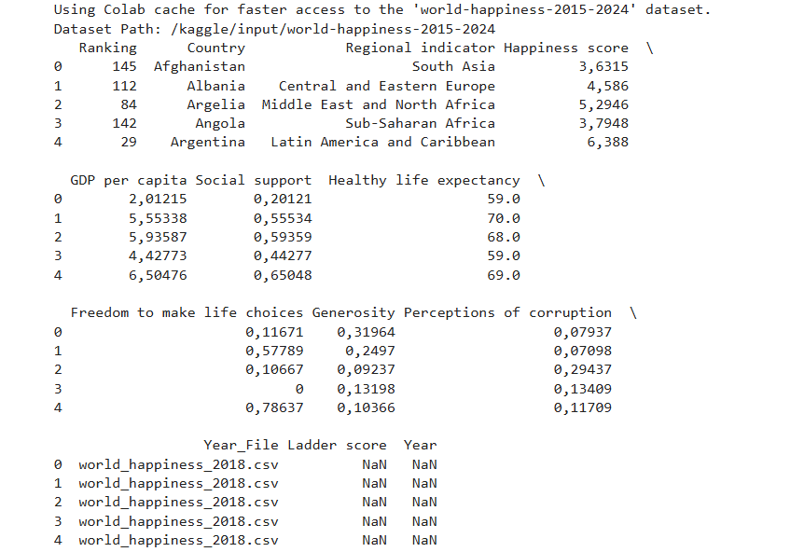

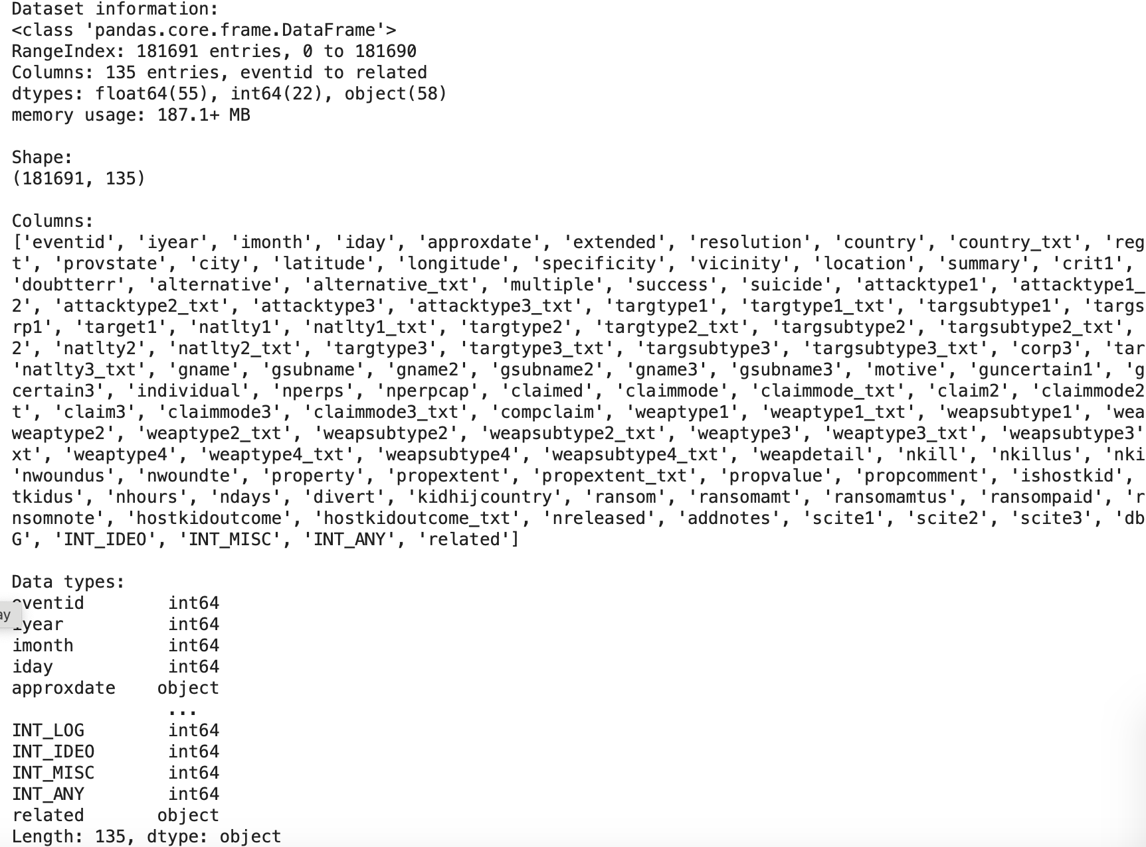

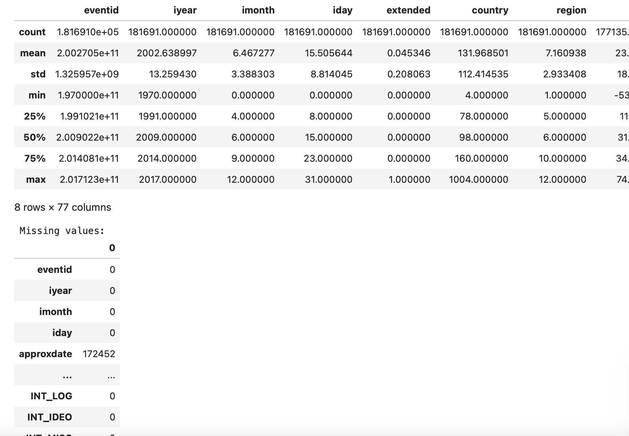

Result:

